**[DOING PHYSICS WITH PYTHON](https://d-arora.github.io/Doing-Physics-With-Matlab/)**

# QUANTUM MECHANICS

**THE HYDROGEN ATOM**

**Ian Cooper**

matlabvisualphysics@gmail.com

**DOWNLOAD DIRECTORY FOR PYTHON SCRIPTS**

**qmH01.py** Solution to the [3D] Schrodinger equation for the hydrogen atom: eigenvalues and eigenfunctions

**qmH03.py** pcolor and surface plots of the probability density in the XZ plane and [3D] views

**qm061.py** azimuthal wavefunctions

**qm061R.py** spherical harmonic and Legendre wavefunctions

**qm061S.py** spherical harmonics on a sphere

**qm061C.py** [3D] plots of the spherical harmonics

**qm061A.py** polar plots and [1D] plots of the spherical harmonics

**qmH01C.py** Radial Schrodinger equation: reduced radial wavefunction

**qmH03.py** Visualization of the wavefunctions for hydrogen

[**GitHub**](https://github.com/D-Arora/Doing-Physics-With-Matlab/tree/master/mpScripts)

[**Google Drive**](https://drive.google.com/drive/u/3/folders/1j09aAhfrVYpiMavajrgSvUMc89ksF9Jb)

**INTRODUCTION**

Hydrogen is the simplest of all the atoms with only one electron surrounding the nucleus. Ions such as He+ and Li2+ are *hydrogen-like* since they also have only a single electron.

In each case, the mass of the electron is much less the nuclear mass, therefore, we will assume a stationary nucleus exerting an attractive force that binds the electron to the nucleus. This is the Coulomb force with corresponding potential energy *Uc*(*r*) is

(1) 

and it depends on the separation distance *r* between the electron and proton.

The Coulomb force between the nucleus and electron is an example of a central force where the attractive force on the electron is directed towards the nucleus. This is a [3D] problem and it best to use **spherical coordinates** (*r,*  *θ,*  *φ*) centered on the nucleus as shown in figure 1. The **radial coordinate** is *r*, *θ* is the **polar angle (0 to π)** and *φ* is the **azimuthal angle (0 to 2π)**.

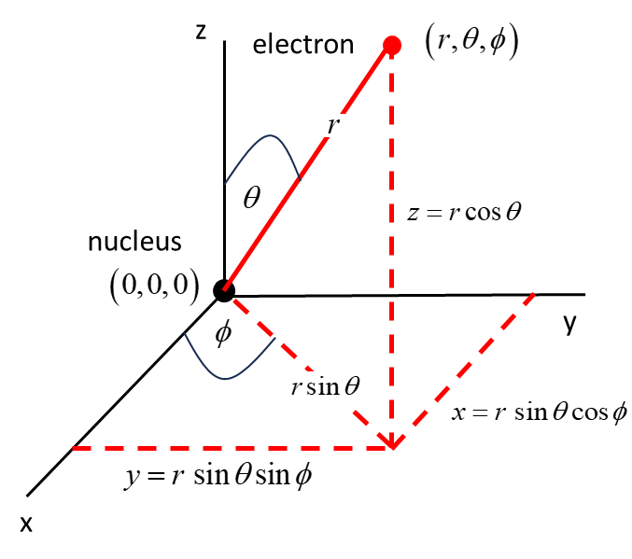

Fig. 1. Spherical coordinates of the electron (*r*, *θ*, *φ*) centered on the nucleus. The distance between the electron and nucleus is *r*, *θ*  is the angle between the *Z*-axis and the radius vector and *φ* is the angle between the *X*-axis and the projection of the radius vector onto the *XY* plane. *θ* ranges from 0 to π and the azimuthal angle *φ* from 0 to 2π.

The time independent Schrodinger Equation in spherical coordinates can be expressed as

(1)



where *μ* is the reduced mass of the system

(2) 

Equation 1 is separable, meaning a solution may be found as a product of three functions, each depending on only one of the coordinates *r*, Θ, Φ. This substitution allows us to separate equation 1 into **three** separate differential equations (equations 4, 6 and 7) each depending on one coordinate *r*, Θ, Φ. For physical acceptable solutions to these three differential equations, it requires three quantum numbers *n*, *l*, and *ml.*

The time independent wavefunction  in spherical coordinates is given by

(3) 

**Principle quantum number *n*** = 1, 2, 3 …

**Orbital angular momentum quantum number**

***l***= 0, 1, 2, … *n*-1

**Magnetic quantum number *ml***= 0, ± 1, ± 2, … , ± *l*

**Azimuthal equation**

The differential equation in Φ is known as the **azimuthal equation** and can be written as

(4)  ***azimuthal equation***

where  .

The solution of the azimuthal equation (equation 4) is the normalized azimuthal wavefunction 

(5) 

The function  has a period of 2π and since all physical quantities are derived from the wavefunction, the wavefunction must be singled valued for *φ* = 0 and 2π. This means that the only physically acceptable solutions for *ml* are *ml* = 0, ±1, ±2, ±3, … .



The real part of  is a cosine function and the imaginary part is a sine function. *ml* gives the number of complete cycles of the azimuthal wavefunction within the range 0 to 2π for *φ* (figure 2).

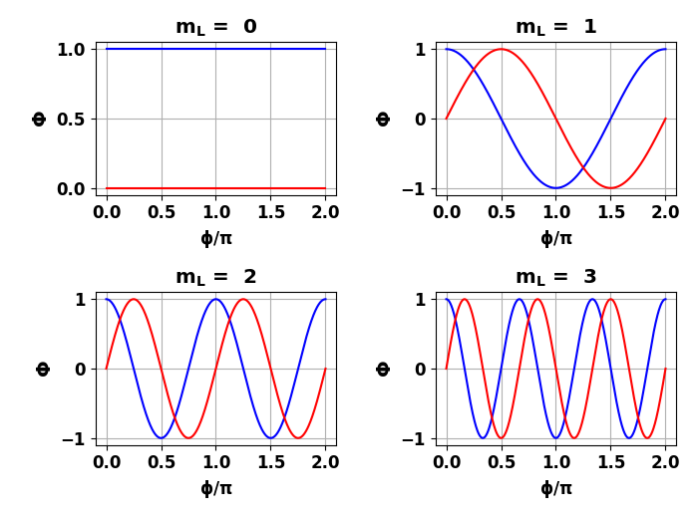

Fig. 2. Azimuthal wavefunction Φ(*φ*) (not normalized): real part a cosine function (blue) and imaginary part a sine function (red). The azimuthal function is single valued at *φ* = 0 and *φ* = 2π rad. *ml* gives the number of cycles in the azimuthal wavefunction for . **qm061.py**

The probability density is

 independent of 

and the probability of finding the azimuthal orientation of the molecule in the region from 0 to  is



So, we never can know the orientation of the molecule, we only know that there is an equal probability of finding the azimuthal angle  when measured.

We can visualize the azimuthal wavefunctions using polar plots as shown in figure 3.

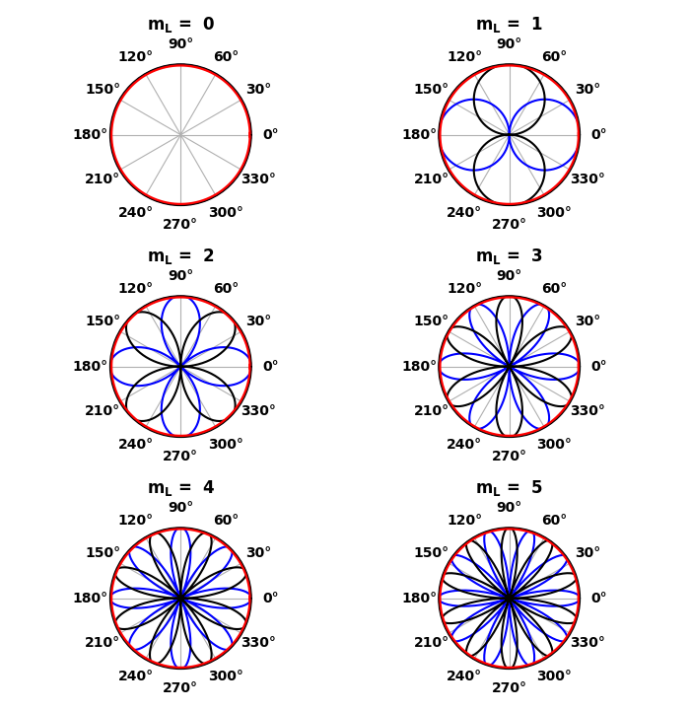

Fig. 3. Polar plots of the real parts (blue), imaginary parts (**black**) of the **azimuthal wavefunction** and the probability density function (red). Note: the probability density is independent of the azimuthal angle  and *ml* gives the number of cycles in the range . **qm061.py**

**Polar equation**

The differential equation for  is called the ***polar equation***

(6) 

Note that the angular equation (equation 6) depends upon the quantum numbers *ml* and *l*. For physically acceptable solutions of equation (6) there must be restrictions on *ml* and *l* as given by



That is, the orbital quantum number *l* must be a zero or a positive integer, and the magnetic quantum number *ml* must be a positive or negative integer or zero and .

The solution of the angular equation was first worked out by the famous mathematician Adrien Legendre (1752 – 1833). Equation (6) is often called the **associated Legendre equation**.

The solutions for the angular equation are polynomials in cos*θ,* and  are known as the ***associated Legendre polynomials*** 

The full angular dependence of the central force wavefunctions are the spherical harmonics 



and the normalized condition is



Note: The probability density function *probD* is independent of the azimuthal angle  since





**Spherical harmonics** are powerful mathematical tools, allowing us to represent any function on a sphere. That is, spherical harmonics are basis functions defined on a spherical surface. A function  defined on the unit sphere can be expressed as



*l* is the degree of the function and can be though of as a “frequency”:

*l* = 1 gives 1 cycle, *l* = 2 gives 2 cycles, ... .

**Visualizing the spherical harmonics**

Even for low values of the quantum numbers, it is hard to visualize the spherical harmonics. For many practical purposes the real quantity  is important. Different ways of displaying the spherical harmonics are shown in the following plots (figures 4).

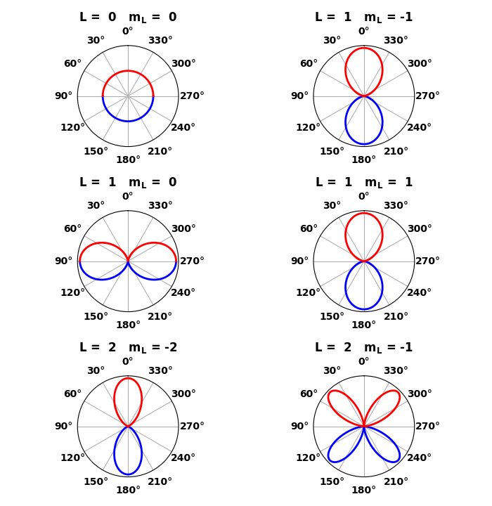

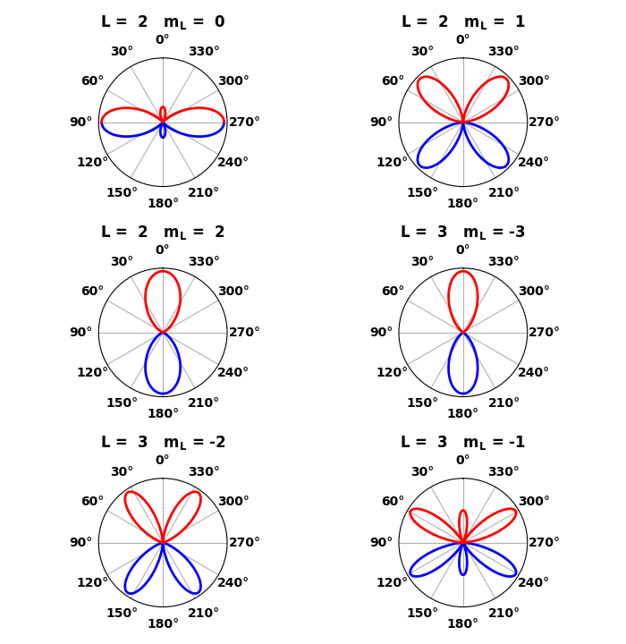

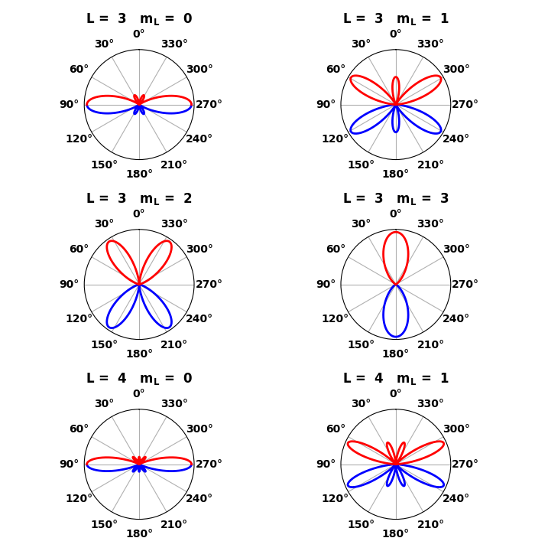

Fig. 4A. Polar plots of the probability density for the alignment of the angular momentum. The Z-axis is along the 0o-180o lines. The probability density is indpendent of the azimuthal angle. Blue and red indicate opposite signs of the wavefunction. The distance from the Origin to the coloured curves is proportional to the probaility density . **qm061R.py**

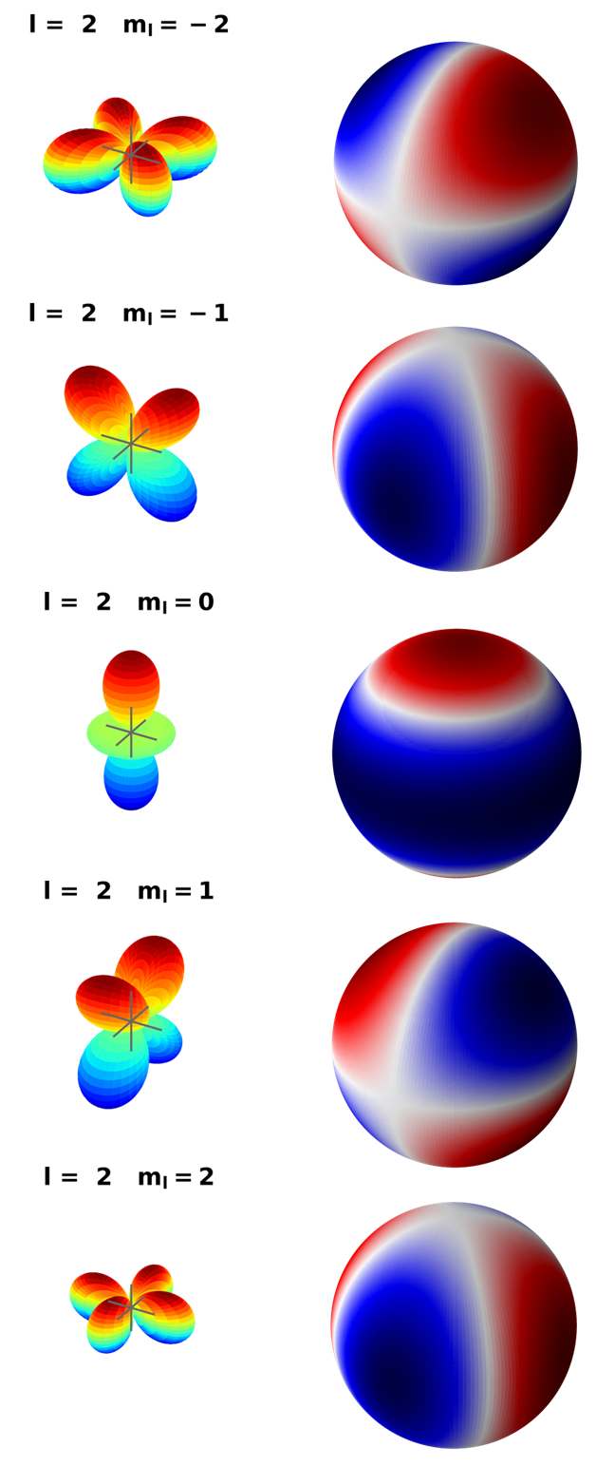

Fig. 4B. Visualization of the spherical harmonics for *l* = 2 on a sphere. **qm061S.py**

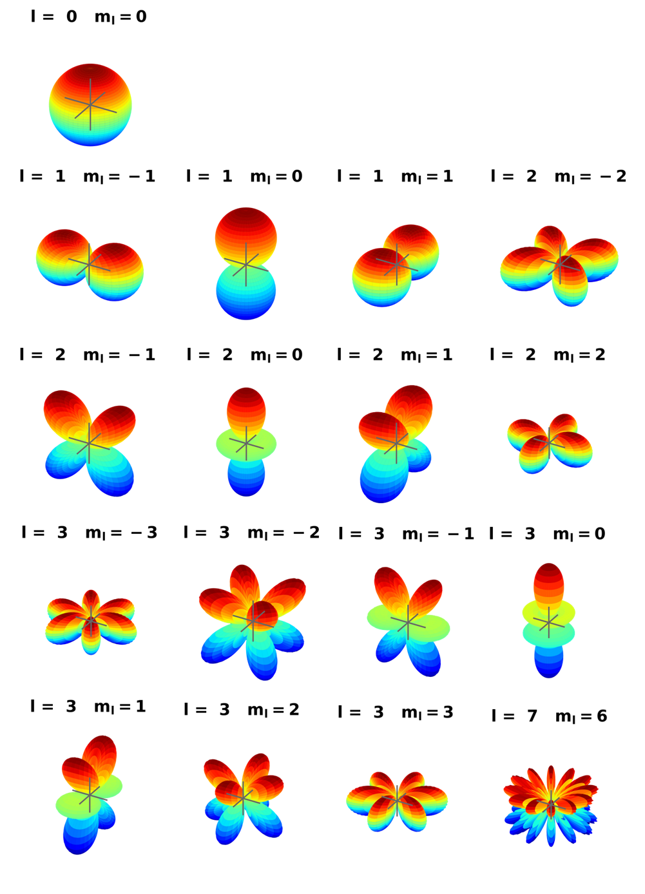

Fig. 4C. Spherical harmonics. Note: that all the spherical harmonics are rotationally symmetric about the Z-axis. In the Python figure window you can [3D] rotate the plots. **qm061C.py**

|  |  |
| --- | --- |
|  |  |
|  |  |
|  |  |

Fig. 4D. Plots for and . In the polar format , if you rotate the curve around the 180o – 0o axis, you can visualize the [3D] pattern for the spherical harmonics. **qm061A.py**

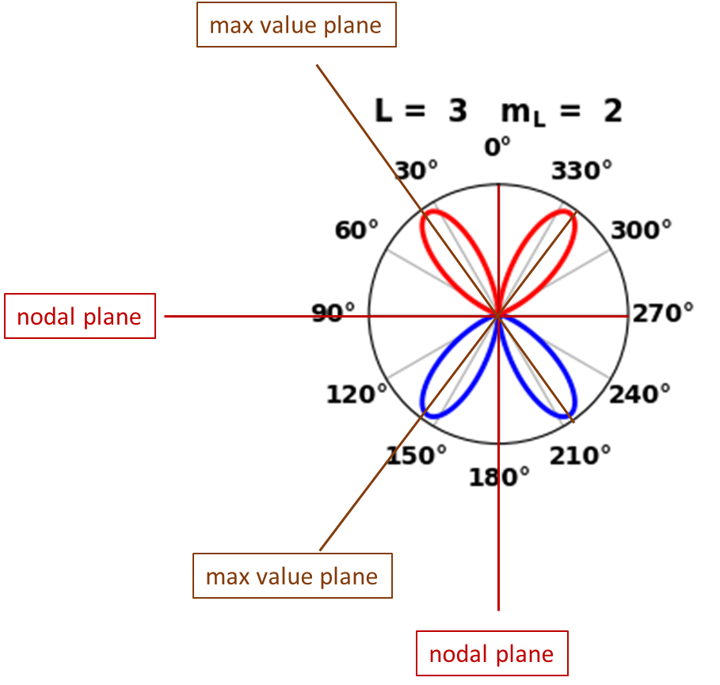

Fig. 4E. Polar plot of probability density for spherical harmonics, l = 3, ml = 2 showing the nodal planes and planes of maximum probability density. **qm061R.py**

Note the way in which the regions of higher probability shift towards the Z-axis from the XY plane as  increases. The probability densities are spherically symmetrical and a view can be imaged by rotating the polar plots around the Z axis.

**Radial equation**

Finally, to complete the process, **the *radial equation***becomes

(7) 

Equation (7) is also known as the ***associated Laguerre equation*** after the French mathematician Edmond Laguerre (1834 – 1886). The ***associated* *Laguerre functions*** are the solutions of the radial equation and are polynomials in *r*.

The differential equations in *φ* (equation 4) and in *θ* (equation 6) are independent of the potential energy function *Uc*(*r*). The total energy *E* and the potential energy *Uc*(*r*) appear only in the radial differential equation (equation 7). Therefore, it is only the radial equation (equation 7) containing the potential energy term *Uc*(*r*) that determines the allowed values for the total energy *E*.

Physically acceptable solutions of the radial equation (equation 7) for hydrogen atom and hydrogen-like ions can only be found if the energy *E* is quantized and has the form

*Total energy E is quantized*

(8) 

where the **principal quantum number** is *n* = 1, 2, 3, … and *n* > *l*. The negative sign indicates that the electron is bound to the nucleus. If the energy were to become positive, then the electron would no longer be a bound particle and the total energy would no longer be quantized. The quantized energy of the electron is a result of it being bound to a finite region. The energy levels of the hydrogen atom depend only on the principal quantum number *n* and do not depend on any angular dependence associated with the quantum numbers *l* and *ml*. Equation (8) is in agreement with the predictions of the Bohr model. In the **Bohr Model** of the atom the total energy *En* is quantized and the electron can only orbit without radiating energy in stable orbits of fixed radii *rBn* given by equation (9).

*Bohr model: allowed stable orbits*

(9) 

For hydrogen-like species, the total energy depends only on the principal quantum number *n*, this is not the case for more complex atoms. For hydrogen like systems, the ground state is specified by the unique set of quantum *n* = 1, *l* = 0, *ml* = 0. For the first excited state *n* = 2, there are four independent wavefunctions with quantum numbers:

*n* = 2 *l* = 0 *ml* = 0

*n* = 2 *l* = 1 *ml* = -1

*n* = 2 *l* = 1 *ml* = 0

*n* = 2 *l* = 1 *ml* = 1

This means that the first excited state is ***four-fold degenerate*** as the total energy *E*2 only depends on the principal quantum number *n*.

We can define a pseudo-wavefunction ***g*(*r*) = *r* *R*(*r*)** which leads to a [1D] Schrodinger Equation

(10) 

where the effective potential energy *Ueff* has two contributions due to the Coulomb interaction *Uc* and the angular motion of the electron *Ul*

(11) 

where  is the reduced mass of the system. We call this the **reduced radial equation** for a hydrogen atom and call *g*(*r*) the **reduced radial function**. The term



is the Hamiltonian operator, *UC* is the Coulomb potential energy function and is due to the attractive between the electron and nucleus. *Ul* is the orbital potential energy function



and when *l* > 0 there is a repulsive interaction between the electron and the nucleus and is called a centrifugal barrier. When

*l* = 0, there is zero centrifugal barrier. For *l* > 0, the centrifugal repulsion dominates over the Coulomb attraction for very small *r* values. Thus, it provides a barrier that becomes infinite as the electron-nucleus separation tends to zero, keeping the electron and nucleus apart. Figure 5 shows the potential energy functions for the cases when *l* = 0, 1, and 2 (**qmH01.py**).

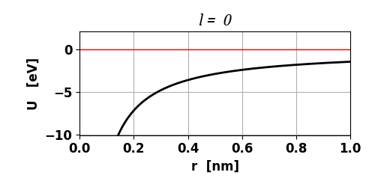

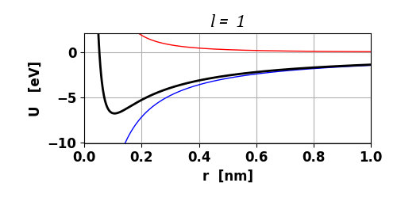

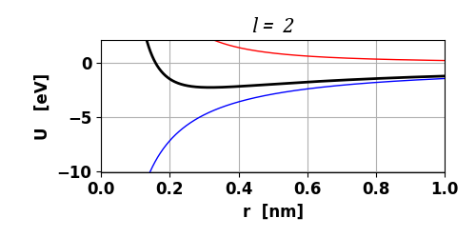

Fig. 5. The effective potential (**black**), the Coulomb potential (**blue**) and the orbital potential (**red**) for the hydrogen atom. *l* = 0 has no minimum, but for *l* > 0, there is a minimum in the curve, and this moves to larger electron-nucleus separations as *l* increases.

**PROBABILITY DENSITY**

In the Bohr theory of the hydrogen atom, the electron was pictured as orbiting around the nucleus in a simple circular orbit. The position vector of the electron was well defined. However, in quantum terms the electron’s position is not well defined and we must use the wavefunction  to calculate the probability distribution of the electron in the state (*n* *l* *ml*).

Also, in many applications in atomic physics it is important to know the behaviour of the wavefunctions since measurable quantities can be obtained by calculating various expectation values.

From the wavefunction of a given state (*n l ml*), we can calculate the probability of finding an electron from the corresponding ***probability density function***

(12)



The probability of finding the electron does not depend upon the azimuthal angle *φ* and the azimuthal probability density gives a uniform probability – all values of *φ* are equally likely, since

(13) 

hence

(14)



The normalization conditions are

(15A) 

(15B) 

The radial wavefunction *Rn l* (*r*) can be used to calculate the radial probability distribution of the electron, that is, the probability of the electron being at a distance *r* from the nucleus and it depends on both *n* and *l*.

We are interested in finding the probability *P*(*r*) *dr* of the electron being in a thin shell of radius *r* and thickness *dr*. The differential volume element in spherical polar coordinates is



Therefore,

(16) 

Using the reduced radial wavefunction *g*(*r*) = *r* *R*(*r*) and letting *N* be a normalizing constant, the probability of finding the electron with the thin shell reduced to

(17) 

and

(18) 

since the probability of finding the electron is one.

**SOLVING THE SCHRODINGER EQUATION**

We can solve the reduced radial equation in Python using the matrix method by finding the eigenvalues and eigenfunctions. The angular dependence is given by the spherical harmonics.

Typical input values and default values:

number of grid points, *n* = 999

principal quantum number, *n* = 1

orbital quantum number, *L* = 0 (*L* used not *l*)

magnetic quantum number mL = 0

nuclear charge, *Z* = 1

min radial distance, *rMin* = 1x10-18 m

max radial distance, *rMax* = 5x10-9 m

num of eigenvalues returned, *num* = 100

**Energy eigenvalues**

A summary of the energy eigenvalues [eV] is given in Table 1. *n* is the principal quantum number, *ET* are the theoretical values (equation 8), and *EB* (*EB = -E*) are the numerically calculated binding energy for different *l* values. We have the restriction that *l* < *n*, therefore, when *l* = 2, then the lowest energy state is *n* = 3 as shown in Table 1. The binding energies *EB* are independent of the value of orbital angular momentum quantum *l*.

Table 1. Computed binding energies for *rMax* = 5 nm

|  |  |  |  |  |  |  |  |
| --- | --- | --- | --- | --- | --- | --- | --- |
| *n* | 1 | 2 | 3 | 4 | 5 | 6 | 7 |
| *ET* | 13.61 | 3.40 | 1.51 | 0.85 | 0.54 | 0.38 | 0.28 |
| *EB*  *l* = 0 | 13.58 | 3.40 | 1.51 | 0.85 | 0.54 | 0.38 | 0.25 |
| *EB*  *l* = 2 |  |  | 1.51 | .85 | 0.54 | 0.38 | 0.26 |

**There are some problems with the accuracy of the Matrix Method due to the maximum range for the radial coordinate** *rmax*. If *rmax* is too small than the energy eigenvalues near the top of the potential well will be inaccurate. However, if *rmax* is large, then the numerical procedure has difficulties in calculating the eigenvalues. The real potential diverges to infinity as *r* approaches zero. In our modelling, the potential energy function is truncated at some value of *rMin* =1x10-18 m. For larger *n* values the maximum radial coordinate must be large otherwise the results are inaccurate because for large *n* values the electron is most likely to be found at large distances from the nucleus. The default value for the maximum radius is *rMax* = 5x10-9 m. Decreasing *rMax* improves the accuracy for the lowest energy values but the higher energy eigenvalues are not found:

rMax= 2 nm, E1 = -13.594 eV; rMax = 5 nm, E1 = -13.576

rMax = 10 nm, E1 = -13.515 eV

The energy spectrum for the hydrogen atom is shown in figure 6.

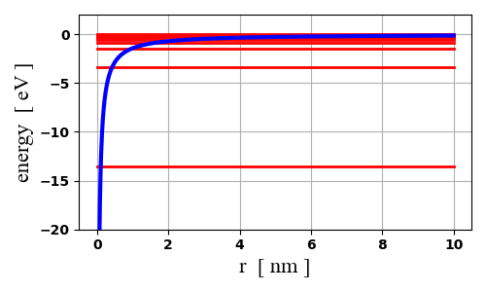

Fig. 6. The effective potential *U* and the energy eigenvalues *En* for a hydrogen atom. For large values of *n* the eigenvalues become very closely spaced in energy since *En* approaches zero as *n* approaches infinity . The intersection of the curves for *U* and *En* which defines one end of the classically allowed region moves out as *n* increases. **qmH01.py**

**Eigenfunctions**

The angular wavefunctions are given by the spherical harmonics and using the Matrix Method for solving the reduced radial Schrodinger equation, we can compute the reduced radial eigenfunctions.

Plots of the radial wavefunctions and radial probability density functions for the electron in a one-electron atom for differing (*n, l*) combinations are shown in figure 7. The figures show the eigenstate (*n*, *l*), the eigenvalue *En*, and the location of the peak in the probability density ***rPeak*** and the expectation value for the location of the electron **< *r* >**.

It is customary for historical reasons to use letters for the various values of *l*. to specify the state of the system.

|  |  |  |  |  |  |  |
| --- | --- | --- | --- | --- | --- | --- |
| *l* | 0 | 1 | 2 | 3 | 4 | 5 |
| letter | s | p | d | f | g | h |

The letters arose from visual observations of spectral lines: **s**harp, **p**rinciple, **d**iffuse, and **f**undamental. After *l* = 3 (f state), the letters generally follow the order of the alphabet.

Although the wavefunction is not a measurable quantity, we can use this function to calculate the expected result of the average of many measurements of a given quantity – this result is known as the **expectation value**. Any measurable quantity for which we can calculate the expectation value is called a **physical observable**. The expectation values of physical observables must be real because experimental measurements are real quantities. expectation values.

**State 1s**: Theoretical values *EB* = 13.61 eV *rB* = 0.0529 nm

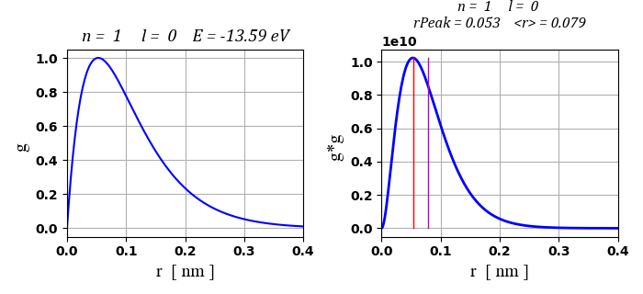

**State 2s**: Theoretical values *EB* = 3.403 eV *rB* = 0.212 nm

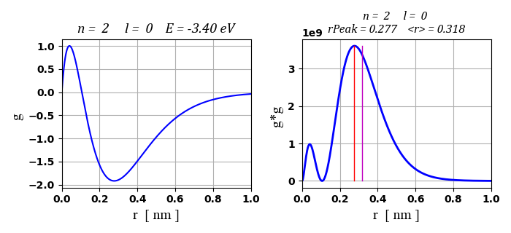

**State 2p**: Theoretical values *EB* = 3.403 eV *rB* = 0.212 nm

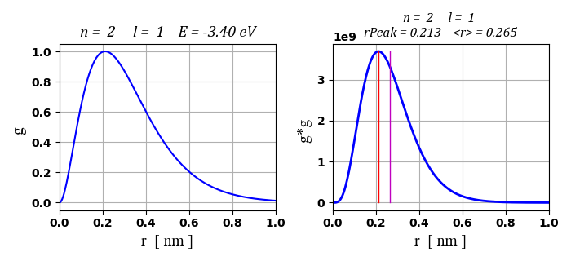

**State 3s**: Theoretical values *EB* = 1.511 eV *rB* = 0.477 nm

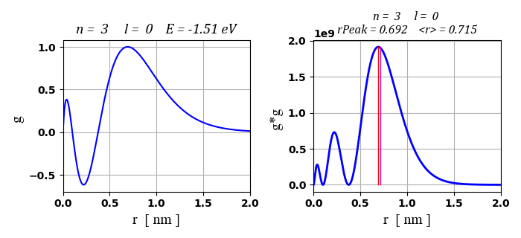

**State 3p**: Theoretical values *EB* = 1.511 eV *rB* = 0.477 nm

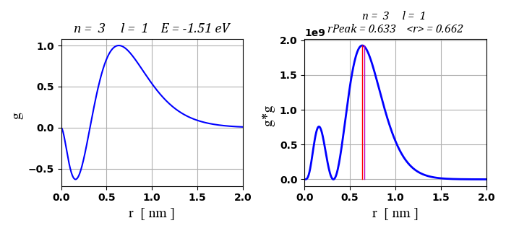

**State 3d**: Theoretical values *EB* = 1.511 eV *rB* = 0.477 nm

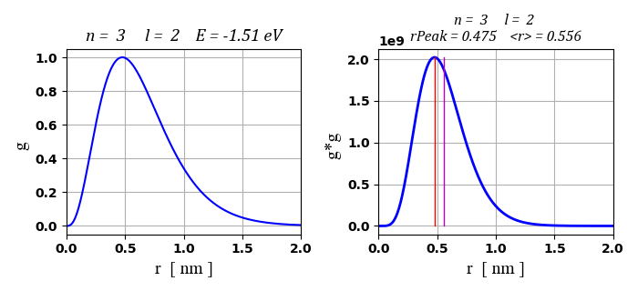

**State 4s**: Theoretical values *EB* = 0.850 eV *rB* = 0.847 nm

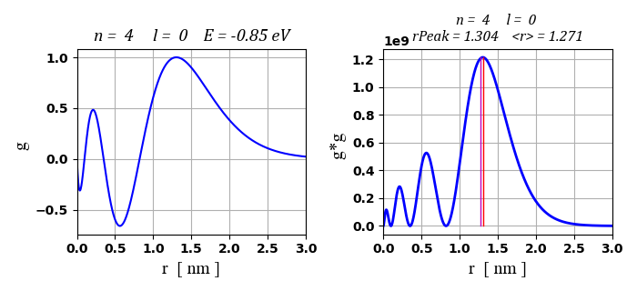

**State 4p**: Theoretical values *EB* = 0.850 eV *rB* = 0.847 nm

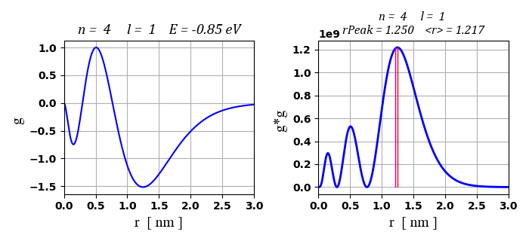

**State 4d**: Theoretical values *EB* = 0.850 eV *rB* = 0.847 nm

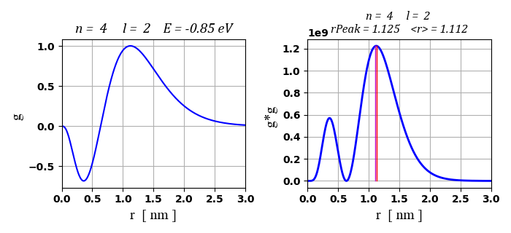

**State 4f**: Theoretical values *EB* = 0.850 eV *rB* = 0.847 nm

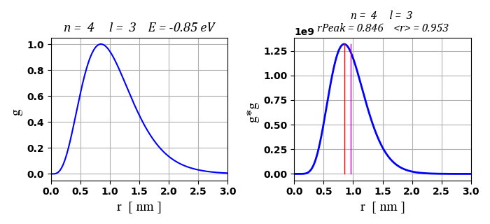

Fig. 7. The reduced radial wavefunctions and probability densities for the electron in a hydrogen atom.

For a state ( *n, l* ), the number of peaks in the probability density plots is ( *n* - *l* ), for example, the shell *n* = 4:

|  |  |  |
| --- | --- | --- |
| **subshell** | ***l*** | **No. peaks** |
| s | 0 | 4 |
| p | 1 | 3 |
| d | 2 | 2 |
| f | 3 | 1 |

Inspection of the plots figure 7 show that the radial probability for a given combination of (*n, l*) have appreciable values only in restricted ranges of the radial coordinate, hence, the electron is most likely to be found within a thin shells region surrounding the nucleus. The radius of each shell is mainly determined by the principal quantum number *n* and with a small angular *l* dependence.

The Bohr model of the hydrogen-like atoms gives allowed stable circular orbits of radii

*Bohr radius* 

Solutions of the Schrodinger Equation show that radii of the shells are of approximately the same size as the circular Bohr orbits. The total energy becomes more positive with increasing *n*, so the region of the radial coordinate *r* for which *E* > *U*(*r*) is greater with increasing *n*, that is, the shells expand with increasing *n* because the classically allowed regions expand.

Figure 7 shows that the details of the structure of the radial probability density functions do depend upon the value of the orbital angular momentum quantum number *l*. For a given *n* value, the probability density function has a strong single maximum when *l* has its largest possible value. When *l* takes on smaller values, additional weaker maxima develop inside the strong one. The smallest value of *l* gives the greatest number of maxima. When *l* = 0 there is a higher probability of the electron being in the region near the origin (*r* = 0), this means that only for s states (*l* = 0) will there be an appreciable probability of finding the electron near the nucleus. A summary of the Bohr radii *rB*, the expectation values <  r > and radii for the most probable location *rPeak* for different combinations of *n* and *l* given in Table 2.

Table 2.

|  |  |  |  |
| --- | --- | --- | --- |
| State (*n l ml*) | *rBn*  [nm] | *rPeak*  [nm] | *< r >*  [nm] |
| 1s (1 0 0) | 0.053 | 0.053 | 0.079 |
| 2s (2 0 0) | 0.221 | 0.277 | 0.318 |
| 2p (2 1 0) | 0.221 | 0.213 | 0.265 |
| 3s (3 0 0) | 0.477 | 0.692 | 0.715 |
| 3p (3 1 0) | 0.477 | 0.633 | 0.662 |
| 3d (3 2 0) | 0.477 | 0.475 | 0.556 |
| 4s (4 0 0) | 0.848 | 1.304 | 1.271 |
| 4p (4 1 0) | 0.848 | 1.250 | 1.217 |
| 4d (4 2 0) | 0.848 | 1.125 | 1.112 |
| 4f (4 3 0) | 0.848 | 0.846 | 0.953 |

For a given *n* value, the radius *rPeak* at which has the highest probability concentration agrees most closely with the Bohr radius *rB* is the state with the highest value of *l* and is the probability density function which has a single peak at a smaller value of *r* than those states with smaller *l* values. For a given *n* value, the average radial distance < *r* > from the nucleus increases with decreasing *l* values.

Figure 8 shows two-dimensional views of the probability density functions for different electron states (*n* *l* *ml*) of the hydrogen atom. To image a three-dimensional view, rotate the image through 360o, there being axial symmetry about the Z-axis in each case.





The images are produced using the Code **qmH03.py**. The values of *n*, *l*, and *ml* are entered in the INPUT section of the Code. You must remember that *l* = 0, 1, 2, 3, … , *n*-1 (*l* < *n* ) and . Also, you may need to chnage the maximum separation distance *rMax*.

Fig. 8. (below) Probability density for eigenfunctions of the hydrogen atom in the XZ-plane, with the Z-axis pointing up the page.

